Progress of sowing and agricultural crops details During Rabi Season 2021-22.
(30.10.2021)

2021-22 Agricultural Production:

Anticipating timely and well distributed rainfall during pre-monsoon, southwest & northeast monsoon period in 2021-22 it was programmed to cover 77.00 lakh hectares, 28.00 lakh hectares and 5.00 lakh hectares during Kharif, Rabi and Summer seasons respectively, totally 110.00 lakh hectares under agricultural crops. Proposed production target for Food grains and Oilseeds were 135.48 lakh tonnes and 15.23 lakh tonnes respectively.

Sl.No. | Crops | Area (Lakh Hectares) | Production (Lakh Tonnes)
1. | Cereals | 45.91 | 112.69
2. | Pulses | 33.84 | 22.79
 | Total Food Grains | 79.76 | 135.48
3. | Oilseeds | 15.08 | 15.23
4. | Commercial Crops
i) | Cotton | 7.77 | 21.37 Lakh Bales
ii) | Sugarcane | 6.68 | 521.97
iii) | Tobacco-VFC | 0.71 | 0.64
 | Total Area | 110.00

2021-22 Kharif Agricultural Production:

During Kharif 2021 total of 77.00 lakh hectares area has been set as target for sowing under different crops. Similarly, in the area of 78.51 lakh hectare sowing.

Sl.No. | Crops | Area (Lakh Hectares) |  | Production (Lakh Tonnes)
 |  | Targeted Area | Sown Area
1. | Cereals | 31.37 | 33.67 | 87.73
2. | Pulses | 21.07 | 21.18 | 14.16
 | Total Food Grains | 52.44 | 54.85 | 101.88
3. | Oilseeds | 10.67 | 10.11 | 10.85
4. | Commercial Crops
i) | Cotton | 7.30 | 6.39 | 21.04 Lakh bales
ii) | Sugarcane | 5.88 | 6.39 | 455.80
iii) | Tobacco-VFC | 0.71 | 0.76 | 0.63
 | Total Area | 77.00 | 78.51
2021-22 Rabi Agricultural Production:

During Rabi 2021 total of 28.00 lakh hectares area has been set as target for sowing under different crops.

Sl.No. | Crops | Area (Lakh Hectares) |  | Production (Lakh Tonnes)
 |  | Targeted Area | Sown Area
1. | Cereals | 11.92 | 2.91 | 16.43
2. | Pulses | 12.69 | 5.21 | 8.62
 | Total Food Grains | 24.61 | 8.12 | 25.05
3. | Oilseeds | 2.50 | 0.81 | 2.29
4. | Commercial Crops
i) | Cotton | 0.46 | 0.09 | 0.31 Lakh bales
ii) | Sugarcane | 0.43 | 0.14 | 37.74
iii) | Tobacco-VFC | 0.00 | 0.00 | 0.00
 | Total Area | 28.00 | 9.16

Rainfall:

During Rabi 2021, dated: 30.10.2021 normal average rainfall was 3 mm against actual rainfall 2 mm (-28%). District wise rainfall data is attached in Annexure-1.

Totally (October-1st to October-30th) normal average rainfall was 129 mm against actual rainfall 176 mm.(36%).

Rabi 2021 Area coverage:
During Rabi 2021 total of 9.16 lakh hectares (33%) has been sown against a set target of 28.00 lakh hectares by 30.10.2021, Cropwise and districtwise area sown details was provided in annexure 2 and 3.

Supply of Agricultural Tools:

Seeds and fertilizer are the main agricultural commodities for farmers for distribution at Raitha Samparka Kendra (RSK) in all taluks.

Seeds:

For Rabi 2021-22, 3.53 lakh qtls seeds were estimated as demand for sowing and till dated: 30.10.2021, 166109.76 qtls seeds have been distributed at Raitha Samparka Kendras (RSK). Remaining balance of 62917.23 qtls stock is available at RSK .
Fertilizer:

For Rabi 2021-22, total fertilizer demand was estimated at 16.94 lakh metric tonnes and arrangement has been made for timely implementation at various stages till 30.10.2021 total of 2.66 lakh metric tonnes fertilizer has been supplied and the available stock is 6.05 lakh metric tonnes.

ANNEXURE -1
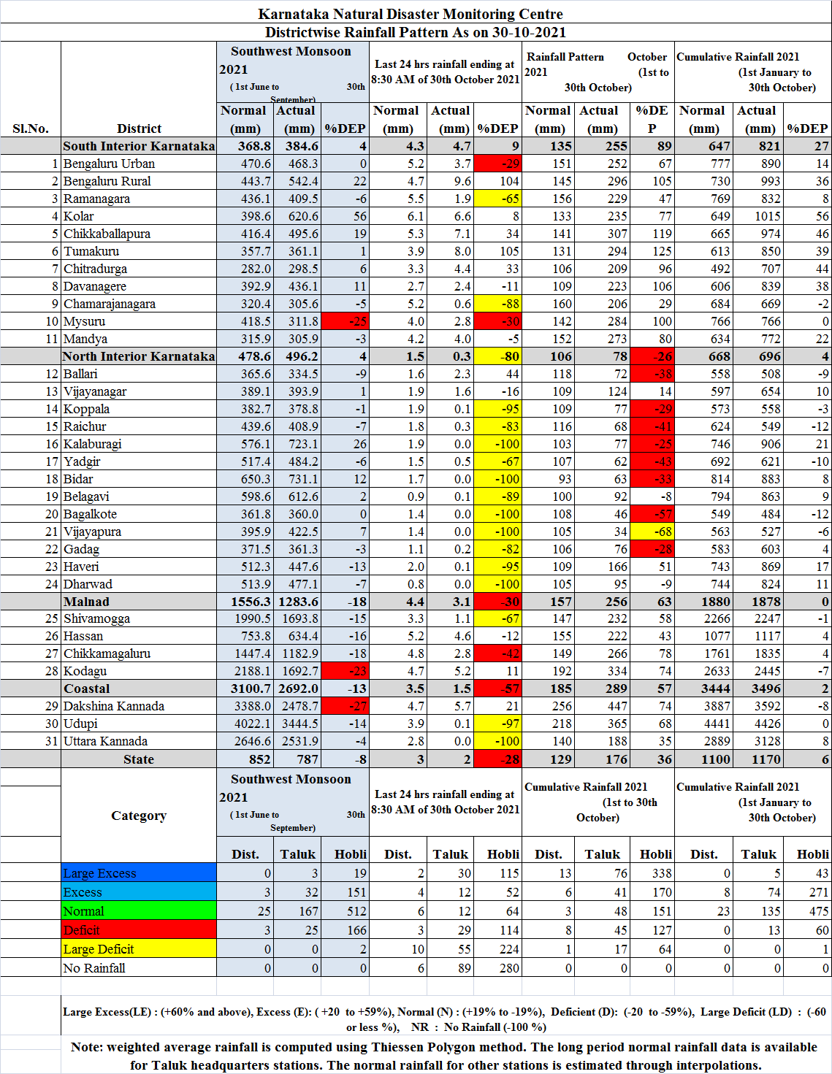
ANNEXURE -2
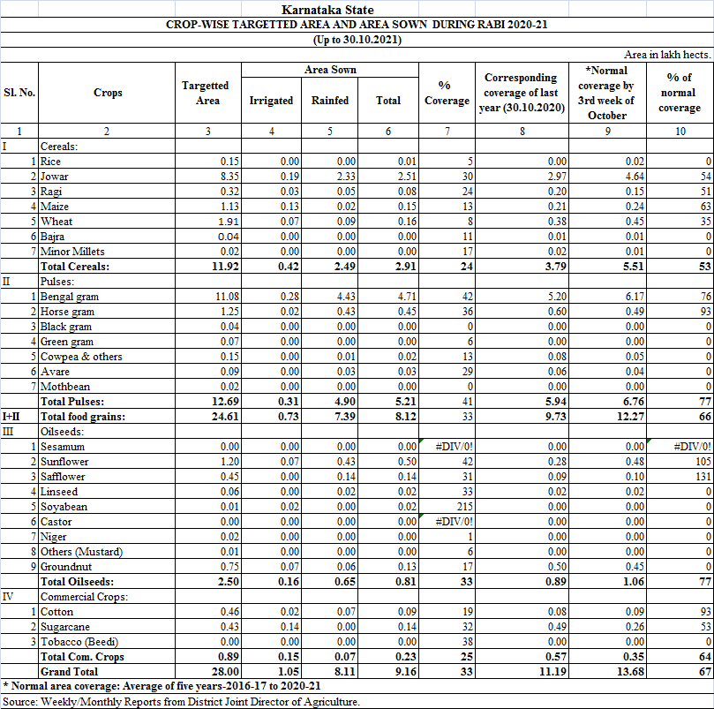
ANNEXURE -3
